# Names:Muhirwa Singiza Shekinah

# Documentation of the Final Project Web Technology and Internet

**Style Fusion Documentation**

**Introduction**

Welcome to the documentation for Style Fusion, a platform designed to assist models in registering themselves and connecting with their respective agencies. This documentation will guide you through the features, functionalities, and benefits of Style Fusion.

**Overview**

Style Fusion aims to create a seamless experience for models and agencies, facilitating efficient communication and collaboration. By utilizing this platform, models gain the opportunity to enhance their careers and gain valuable experience, while agencies can effectively manage and promote their roster of talent.

**Key Features**

1. Model Registration
   * Models can create an account on Style Fusion by providing their personal details, including contact information, measurements, portfolio images, and relevant experience.
   * Secure authentication mechanisms ensure the privacy and confidentiality of model profiles.
2. Profile Management
   * Models can update their profiles with the latest information, including measurements, portfolio updates, and availability.
   * Models can upload and manage their portfolio images, showcasing their work to agencies and potential clients.
   * Models have the option to set their availability status and preferences for various types of assignments.

**Benefits**

1. Enhanced Visibility
   * Models gain exposure to a wide range of agencies and potential clients, increasing their chances of securing more opportunities and collaborations.
   * Agencies can discover talented models, expanding their talent pool and reaching a larger audience.
2. Targeted Talent Search
   * Agencies can leverage advanced search filters to find models that precisely match their requirements, ensuring optimal talent selection.
   * Models can explore job opportunities that align with their preferences, allowing them to focus on the assignments that best suit their expertise.
3. Professional Growth
   * Models can gain valuable experience by working with a variety of agencies and clients, helping them build their portfolios and advance their careers.
   * Agencies can provide guidance, mentorship, and opportunities for models to grow and develop their skills.

**Conclusion**

Style Fusion provides a comprehensive platform for models to register themselves and connect with agencies, empowering both parties to thrive in the fashion and modeling industry. By leveraging the features and benefits of Style Fusion, models can expand their reach and gain valuable experience, while agencies can efficiently manage their talent and foster professional growth.

**User Documentation**

**Key Features**

1. Authentication and Authorization
   * Style Fusion implements Spring Security for authentication and authorization purposes.
   * Models and admins have separate roles and access levels, ensuring data privacy and security.
   * Access to specific endpoints and data is restricted based on user roles.
   * If a user tries to access a restricted URL, they will be redirected to an appropriate error page.
2. Model CRUD Operations
   * Models can perform CRUD (Create, Read, Update, Delete) operations on their own profiles.
   * They can create their profiles, view and update their information, and delete their accounts if needed.
   * Model-specific data is isolated from the admin data.
   * Model can delete and update his data.
   * But Admin Can view the data of all the models but not edit it he/she can delete only.
3. Admin CRUD Operations
   * Admins have the ability to perform display on admin-specific data and user accounts.
   * Admin-specific data is isolated from the model data.
4. File Upload and Download
   * Style Fusion supports file upload and download functionalities.
   * Models can upload portfolio images in various formats (JPEG, PNG, etc.) to showcase their work.
   * Admins can upload and manage documents, such as PDF files for job postings or agency-related materials.
   * Users can download files, such as their portfolio they created.

**Technical Documentation**

**Technologies Used**

1. Spring Boot
   * Spring Boot framework is used as the foundation for developing the Style Fusion app.
   * It provides a streamlined development experience, including automatic configuration and dependency management.
2. Java
   * The Style Fusion app is implemented using Java as the primary programming language.
   * Java enables the backend functionality and supports the integration of various libraries and frameworks.

Packages and Project Structure

1. appsecurity
   * This package contains classes related to authentication and authorization.
   * Spring Security is used for implementing secure authentication and role-based access control.
2. config
   * The config package includes configuration classes for the application.
   * It contains settings for data sources, security, and other necessary configurations.
3. controller
   * The controller package houses the controllers responsible for handling incoming HTTP requests and generating appropriate responses.
   * Controllers receive requests from the frontend and communicate with the appropriate services.
4. dto
   * The dto (Data Transfer Object) package contains classes that define the data structures used for communication between the frontend and backend.
   * These classes typically represent request and response payloads.
5. model
   * The model package holds the domain model classes representing entities in the application.
   * These classes are typically mapped to database tables and contain the business logic.
6. repository
   * The repository package includes interfaces or classes responsible for database operations.
   * It provides methods to perform CRUD operations and query the database using frameworks such as Spring Data JPA.
7. services
   * The services package contains classes that implement the application's business logic.
   * These classes interact with the repositories, perform operations on the data, and handle the app's functionality.

Frontend Resources

1. Webpages
   * The frontend of the Style Fusion app consists of webpages that are responsible for user interactions and rendering.
   * The webpages are created using HTML, CSS, and JavaScript.

**ARCHITECTURE OF THE DATABASE**

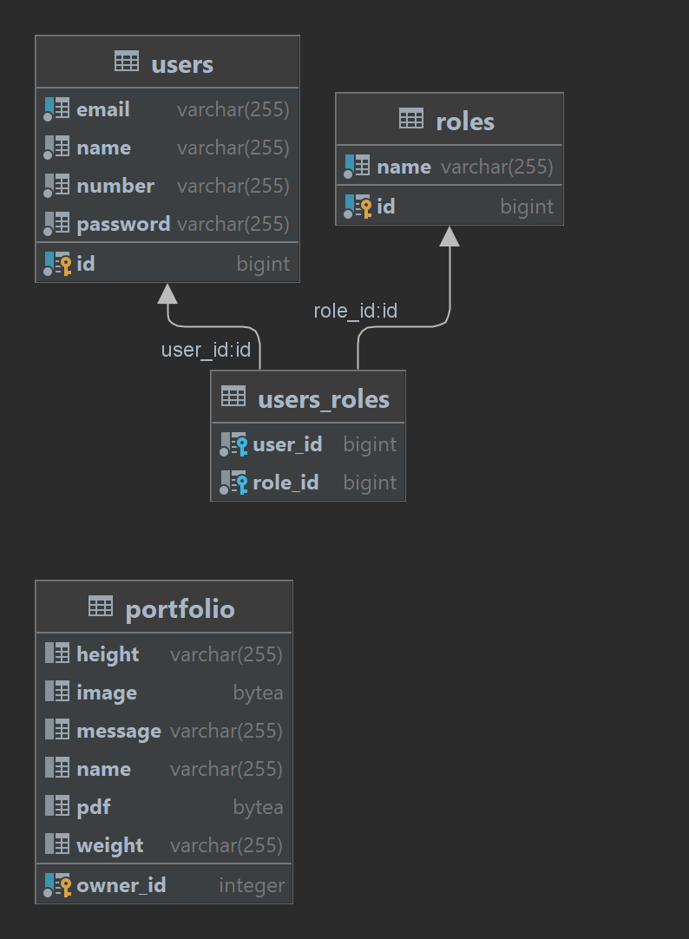

**IN SUMMARY**

Style Fusion is a Spring Boot application built using Java. It provides a platform for models to register themselves and connect with their respective agencies. The app incorporates authentication and authorization using Spring Security to ensure data privacy and security. The backend functionality is organized into several packages, including appsecurity, config, controller, dto, model, repository, and services. These packages handle authentication, configuration, request handling, data transfer objects, entity modeling, database operations, and business logic. Additionally, the app supports file upload and download functionalities for models and admins, allowing them to manage portfolio images and relevant documents. The frontend of the app consists of webpages created using HTML, CSS, and JavaScript, facilitating user interactions and rendering. Overall, Style Fusion aims to streamline communication, enhance visibility, and provide professional growth opportunities for models while empowering agencies with efficient talent management capabilities.

**!!!!!!!CREDENTIALS USED FOR THE APP**

ADMIN: [izereelliela@gmail.com](mailto:izereelliela@gmail.com)

Password:123

MODEL(user): [muhirwasingizashekinah@gmail.com](mailto:muhirwasingizashekinah@gmail.com)

Password:123

Also you can Sign Up as another user and login. And continue on the dashboard to create portfolio

But for the Admin the credentials are those.